Fig. 1: The helmet from the Gladiator School in Pompeii, as appears in Rocca's article (p. 299).
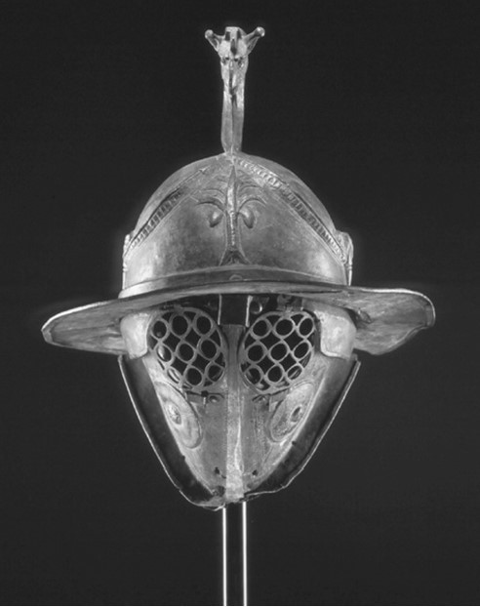
Fig. 2: The graffito in Germanus' grave as appears in Safrai 2001 (p. 74).
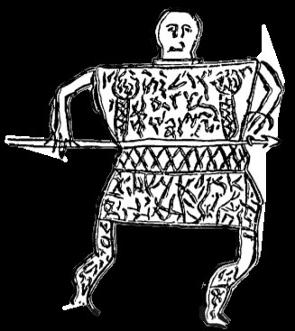

Fig. 3: The sign for the grave of Germanus which was placed by the Israel Nature and Parks Authority. 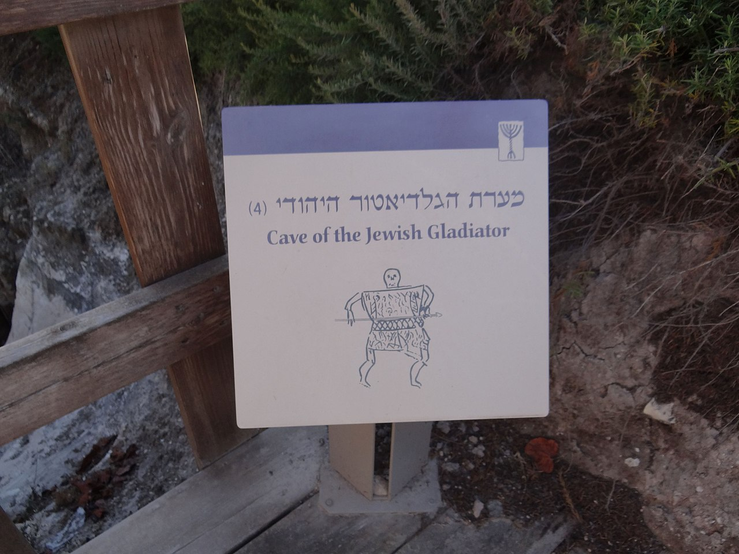
Fig. 4: Depiction of a Roman soldier from the mosaic of Piazza Armerina. 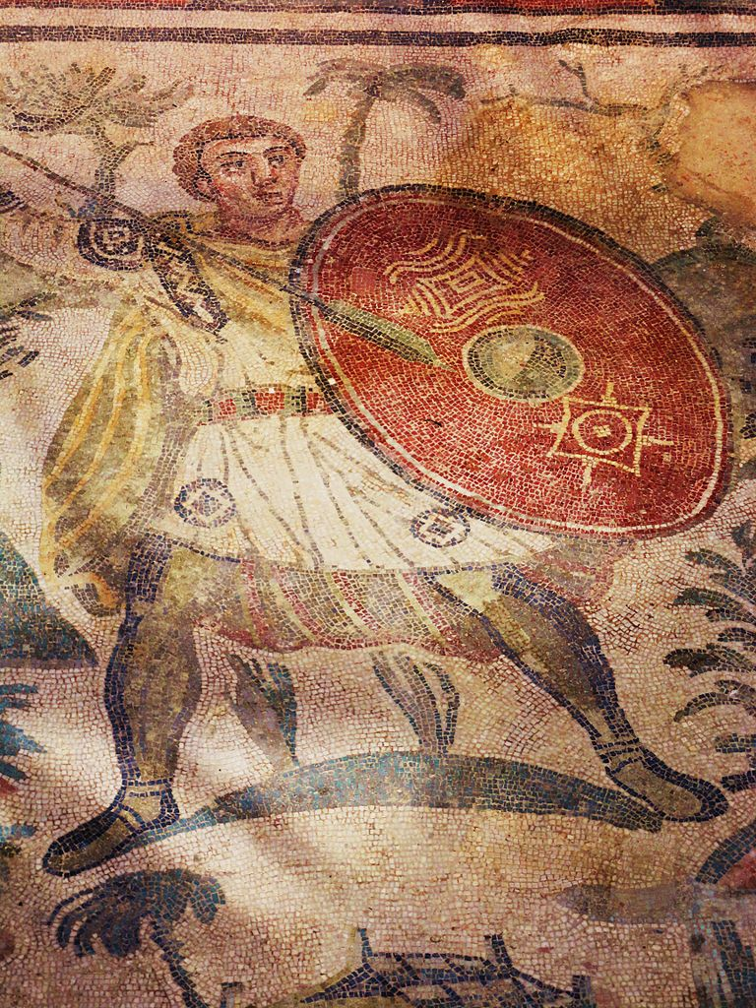
Fig. 5: Depiction of a Roman soldier fighting a beast from the mosaic of Piazza Armerina. 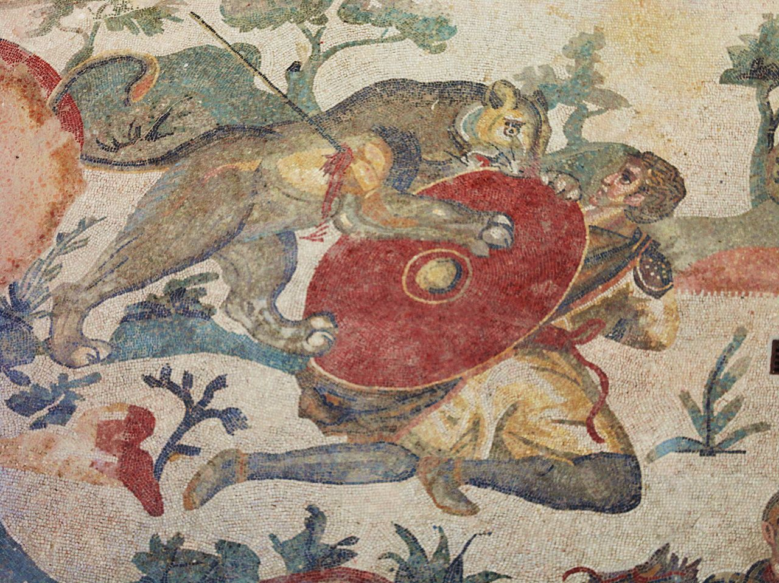
Fig. 6: Depiction of two Roman soldiers from the mosaic of Piazza Armerina. 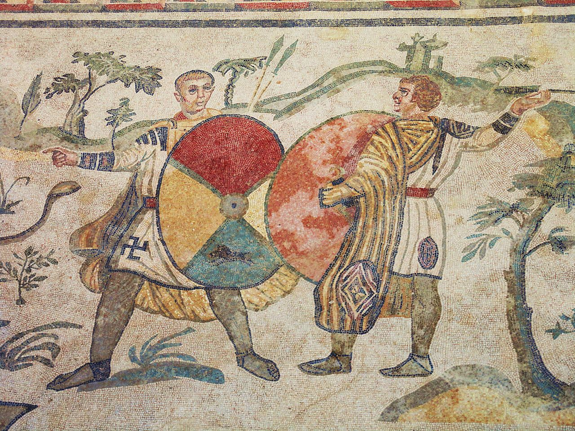
Fig. 7: Description of a venator with a spear and a manica fighting a leopard on a mosaic from the 3rd century found in Bad Kreuznach, Germany.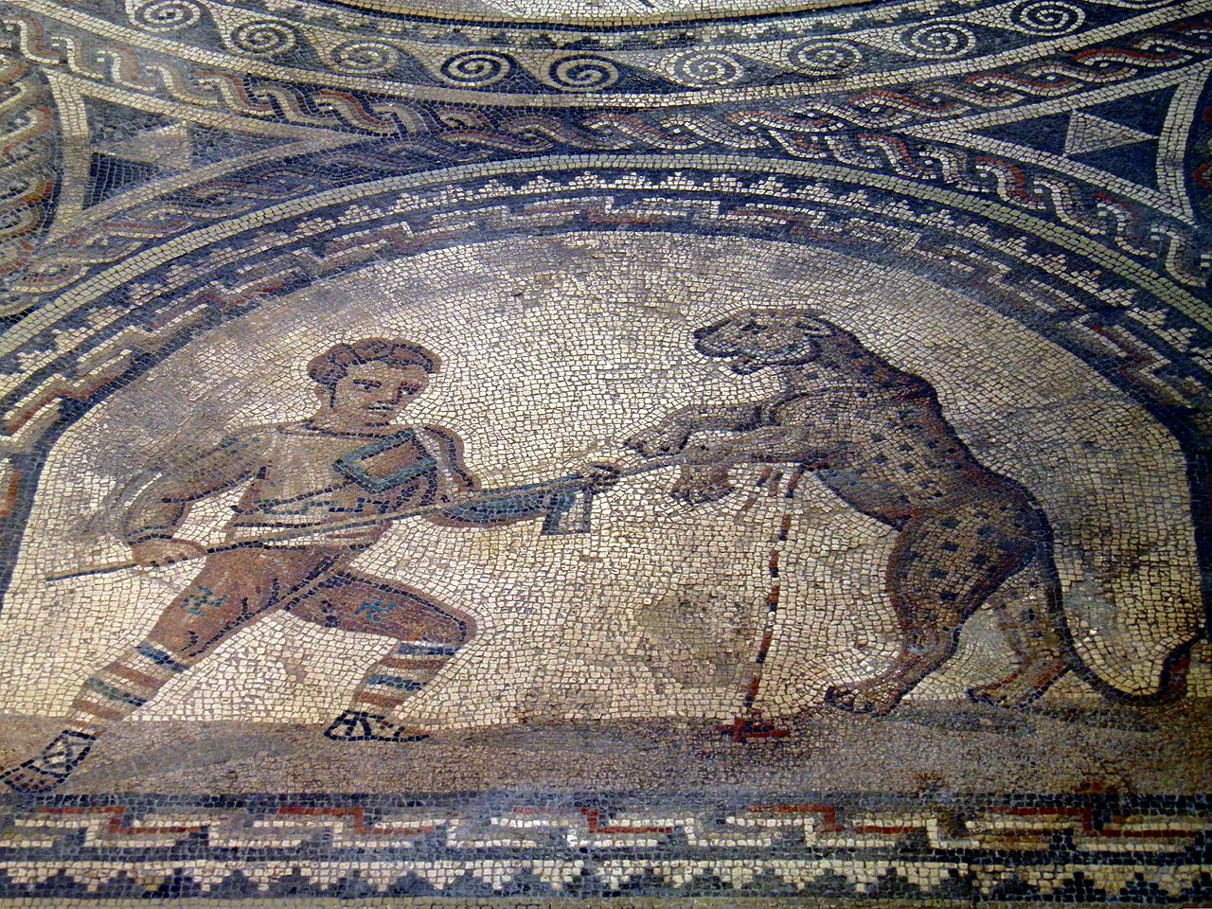
Fig. 8: A mosaic of a fight between venatores and beasts from the 3rd century, found in El Djem, Tunisia. 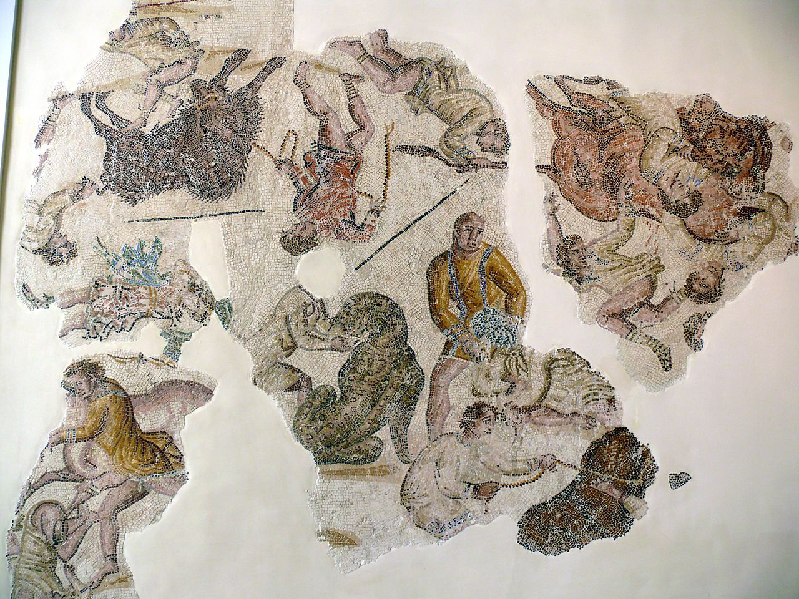

Fig. 9: The section of the graffito from Tel 'Eton of five men holding tridents appeared in Weiss 1995 (p. 17).
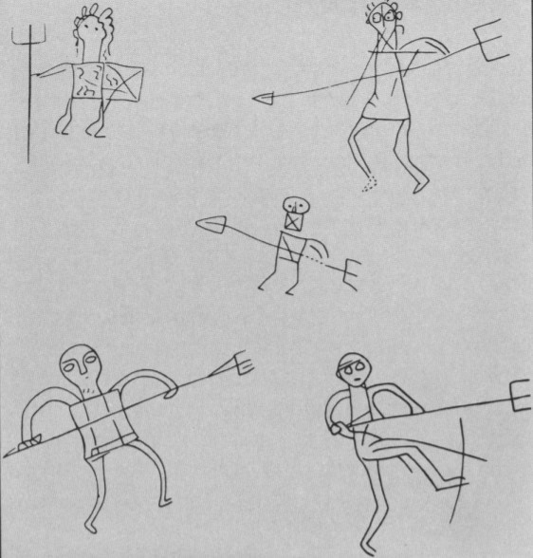
Fig. 10: The graffito from burial cave no. 4 in Bet Shearim appeared in Weiss 1995 (p. 18).
