HAPTIC DEVICES AND TACTILE EXPERIENCES IN MUSEUM EXHIBITIONS

Radu Comes
Department of Design Engineering and Robotics, Technical University of Cluj-Napoca radu.comes@muri.utcluj.ro

Abstract: Museums all around the globe are starting to adopt advanced technologies that enable the visitors to interact with digital replicas of their collections and artworks. Immersive and interactive virtual reality applications represent one of the most appealing and most used technologies within modern museum exhibitions areas. Using these types of applications the visitors can have access to additional layers of information which can be presented in different languages and presented to the visitor when they demand it using advanced digital interactivity. But the major drawback of these applications is that they don’t allow the users to experience tactile exploration regarding the shapes and ornaments of the cultural heritage artefacts. People are programmed to gather and receive sensory information using their sight, hearing but also using tactile experiences. In order to enable tactile experiences within museum exhibitions, modern technologies such as haptic devices can be installed to enable the visitors to examine the shape of the 3D digital replicas of real artefacts. This paper presents a case study of a haptic device instalment within a museum exhibition that can enable real time tactile exploration of digitized artefacts.
Keywords: cultural heritage, 3D models, haptic interface, tactile experiences, museum exhibitions
Introduction
We stand on the brink of a technological revolution that will fundamentally alter the way museum exhibition visitors will interact with cultural heritage assets. This process is driven by the Fourth Industrial Revolution and is characterized by multiple technologies that are blending the physical environment with the digital environment. The speed of current breakthroughs within multiple fields has no historical precedent. Regarding the process of acquiring accurate 3D digital replicas of real cultural heritages the current technologies can obtain very detailed digital assets regarding their shape, material, texture and colour. Therefore the current research within this field is being focused on integrating these detailed 3D models within immersive and interactive applications.
Regarding the tactile exploration of works of art, artefacts and monuments the general guide line is that the visitors are not allowed to touch them. Therefor the most precious artefacts are safely guarded by thick glass walls within museum showcases that allow the visitors to admire them from different predefined angles. Other cultural heritage assets are strategically positioned within the exhibition areas that are out of tactual reach of the visitors ensuring their conservation without having to use dedicated showcases. Even though there are multiple artefacts positioned within tactual reach, most visitors are aware of the tactual restrictions but we as people are programmed to gather and receive sensory information using tactile exploration which is just as important as sight and hearing.
This paper presents a potential solution that can overcome this tactual restriction and enable the visitors to receive sensory information regarding those artefacts that are being safely guarded within thick glass museum showcases. This process can be done either using a haptic device equipment and application. The input data for these applications are detailed 3D scanned models that represent accurate digital replicas of real artefacts.
The shape, texture and colour of artefacts can be obtained using advanced 3D digitization systems such as terrestrial scanners, structured light scanner, laser scanners and photogrammetry solutions. These technologies are usually blended in order to improve the 3D digital replica properties of the final model. Scanners can obtain the shapes and fine details such as ornaments using a very precise mesh that is defined by millions of individual points sampled on the surface of the cultural heritage asset using non-contact systems that ensures that the asset is not damaged during the digitization process. Advanced photogrammetry can obtain better textures and colours from the surface of the artefacts using advanced optical lenses and mapping systems.
There are some modern scanners that can obtain the texture either by using individual vertices colours for each acquired point within a 3D mesh or by using optical lenses, but usually their output quality is not high since they are using smaller optic sensors. Using a dedicated optical system can enable the acquisition of a very detailed colour and texture that is later being processed and carefully mapped over the 3D surface acquired by the 3D laser scanning solution. It is important that multiple texture maps are being created and overlapped in different channels within the visualisation software in order to enable advanced textures.
In order to obtain information regarding the material type, different scientific investigation procedures that make use of physical-chemical methods can be successfully applied. One of the most common experimental techniques is the Fourier-transform infrared spectroscopy (FT-IR) that can analyse the molecular composition of the cultural heritage asset. These types of analyses can vary depending on the type of material such as clay or wood. For metal artefacts different solutions enable the precise composition regarding the material structure.

Haptic devices used in exhibitions
The fields of 3D Scanning, Computer Aided Design (CAD) and Virtual Reality (VR) are being used by museums and universities around the world in order to digitize their collections. The main advantage is the fact that the assets that have been damaged and are incomplete can be recreated within the digital environment using advance computer graphics solutions. Museums have started to develop a strong interest regarding these technologies that enable them to highlight their collections, but they are currently faced with new challenges regarding the design process of the exhibitions areas in order to better integrate these hardware devices such as 3D screens, motions sensors and haptic devices.
The first project that has been focused on the implementation of haptic devices within museum exhibition is The Museum of Pure Form conducted by the research team at PERCRO (engineering laboratory of Scuola Superiore Sant`Anna, Pisa, Italy) and which had partnered with several museums from multiple European countries by hosting and organizing temporary exhibitions of their proposed haptic devices and stereoscopy visualization systems.
Their innovative technical aspects is the fact that anyone visiting the museum could equip the haptic device and interact with the selected art piece by standing in front of the cultural heritage asset, thus making the overall effect more realistic. Their experimental results have shown that most of the visitors have been pleased with the haptic interaction and they have responded positively when questioned about suggesting their friends to visit and experience the haptic tactual exploration of cultural heritage assets.
But beyond all the positive aspects of this system most visitors have complained about the long time required to adapt to the haptic feedback and even more regarding the time required to setup the device for each individual visitor. The authors of this project have also stated the fact that the most important issue regarding using complex haptic devices within permanent museum exhibitions is the fact that they required trained people to setup and adjust the device therefore the overall costs required to keep the system operative is high.
The haptic device installation proposed within this paper represents a much simpler system that offers haptic feedback of some 3D digitized artefacts from the National Museum of Transylvanian History from Cluj-Napoca. The main advantage is the fact that the proposed system does not require to be mounted on the visitor`s arm, therefore it is much more appealing to the general public. The visitors are required to pick up the pen located within the haptic device equipment pen holder and start exploring the tactual feedback of different 3D digitized models. This device does not required trained people in order to setup and start the application making it a viable solution for modern museum exhibitions.
The haptic device used in this case study is the Geomagic Touch System. This haptic device represents a very cost-effective solution constructed of durable metal and moulded plastic components. The equipment has a compact portable design and it has six-degree-of-freedom positional sensing and three-degree-of-freedom force feedback. A haptic device is a motorized equipment that applies force feedback on the user`s hand allowing them to perceive/feel virtual models by producing a touch like sensations when the pen of the device is in contact with the 3D mesh of the virtual model. The application allows the visitors to pick up digital artefacts replicas and reposition them within the virtual environment in order to have access to any areas on their surface. The haptic device instalment within the exhibition area is illustrated in Figure 1.
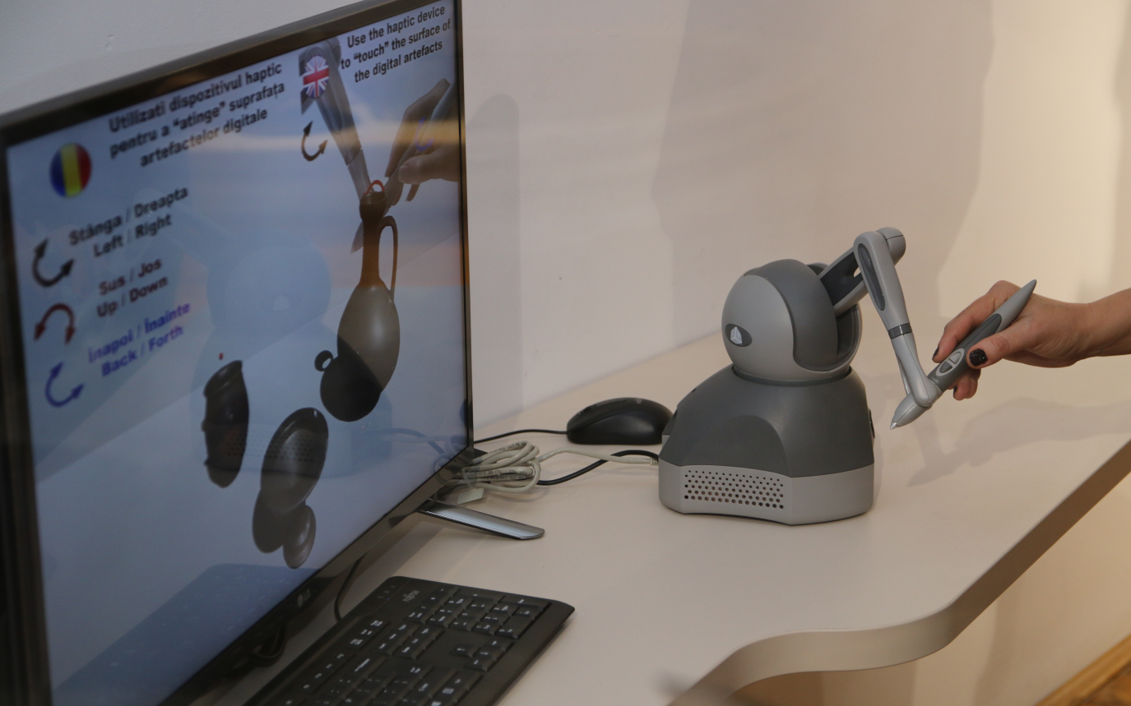
Figure 1. The proposed equipment and application that enables tactile experiences with digital artefacts.
Optimizing 3D digitized artefacts for haptic devices
Visualising complex 3D models that have been generated using different 3D scanner and which contain a very dense mesh composed of multiple millions of polygons can be handled with ease using modern workstations. But in order to display the same models on other devices such as smartphones or tablets the 3D models have to be processed using an optimization method that simplifies their overall geometry from millions to thousands of polygons.
The main drawback of this process is that the fine details from the surface of the scanned artefacts are being eliminated. If the main goal of this step is only to enable the visualization of the artefacts on mobile devices this optimization process can be applied with success. For visualization purposes the fine details that are contained within the geometrical shape of the artefacts can be transferred to the texture layer, this process can be done using photogrammetry mapping techniques.
In order to integrate the 3D model within the haptic application, the collision mesh that will be used for the 3D models requires a simplified 3D model. This optimization step is crucial in order to achieve a good model that can be used to enable the users to perceive the details ornaments from the surface of the scanned artefacts. It is important that the optimization process does not eliminate the fine details acquired by the scanner on the surface of the artefacts in order to allow the haptic device to perceive those surfaces when the user is applying the pen of the haptic device on the virtual surface of the artefact.
The proposed application has been developed within Unity software solution and it makes use of multiple LOD (Level of Details) models as collision bounding areas for each individual artefact surface. These bounding boxes are dynamically loaded in regard to the orientation of the digitized artefacts within the virtual environment allowing the users to trace fine details on the artefact’s surface using the haptic device tactile pen.
The LOD models have a different mesh structures that define the shape of the artefact. These LOD meshes will always have a larger amount of vertices on the faces that is facing the user allowing them to better trace the details on those areas. For the rest of the mesh model that is not facing the viewport the mesh will be simplified and it will still enable force feedback to the haptic device but the fine details will not be available in that area. The user has to pick up the artefact and reposition it using the haptic pen buttons if he wants to explore another area of the artefacts. At this point, when the 3D model is repositioned different LOD models are loaded to ensure that the collision areas for the surfaces that are being orientated towards the viewport are being enabled.
The objects have also been added different mass properties allowing the visitor to experience the difference of virtual picking up a ceramic artefact such as a cup or an iron artefact such as the anvil illustrated in Figure 2.
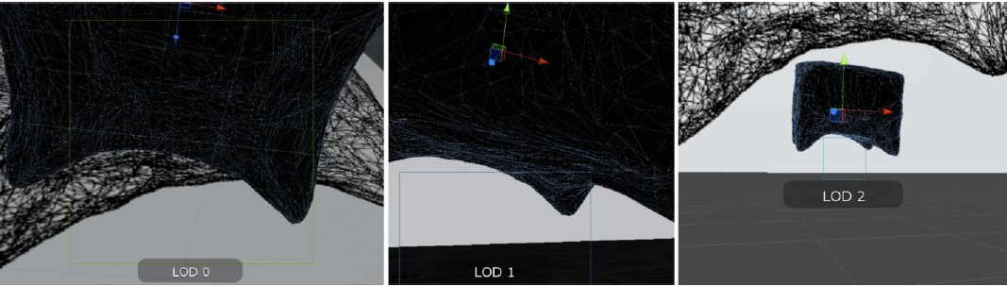
Figure 2. Different LOD models of the same digitized anvil.
The mass properties of the digital replicas have been optimized to allow the visitors to reposition the digital artefacts with ease. Some artefacts such as the anvil presented above are very heavy (the anvil presented above is weighing around 50 kg), making it very difficult to reposition within the real environment. Therefore the mass properties within the virtual environment have been lowered by a large factor. There is a strong force feedback difference when the user is trying to pick up a ceramic vessel using the haptic device or the iron anvil.
This process is done by the electric motors within the haptic device for which the parameters can be programmed accordingly to the design specification of the application. The digitized anvil and the optimized 3D LOD models for each individual side loaded inside the Unity application is illustrated in Figure 3. The haptic interaction have been developed using C# language and it`s based on the OpenHaptics Toolkit developed by Geomagic.

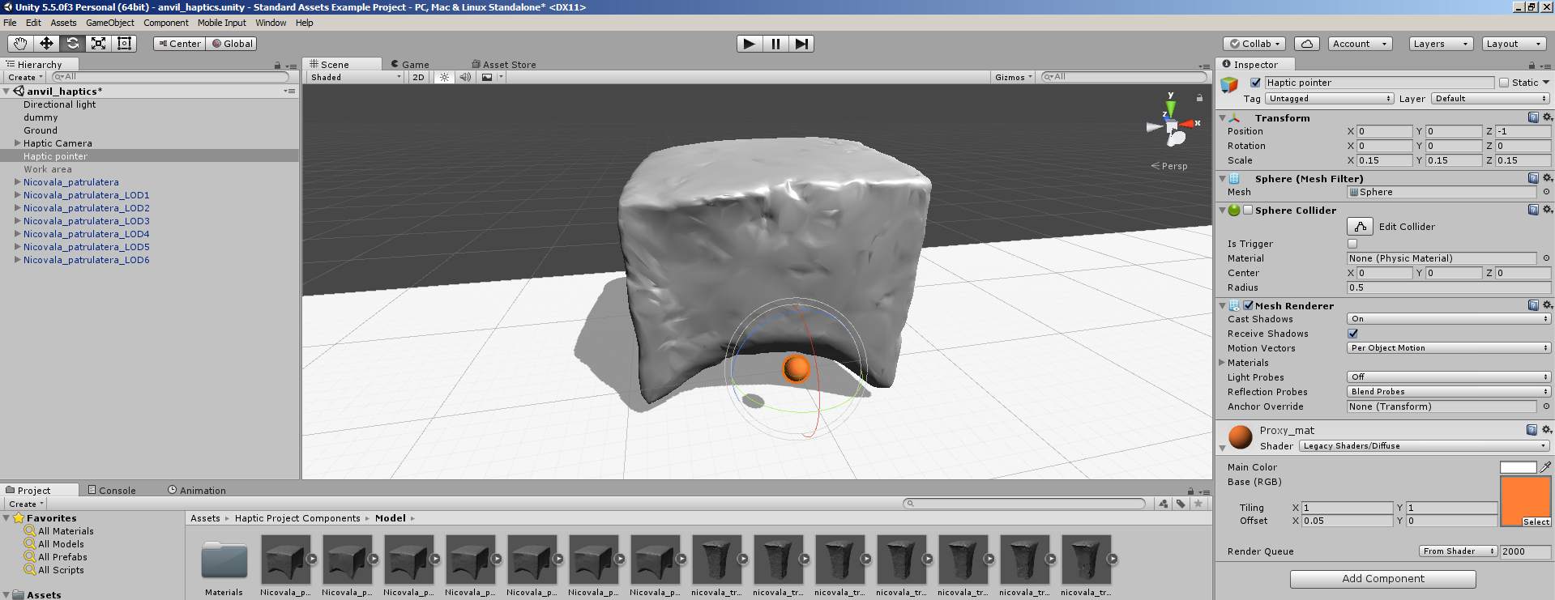
Figure 3. Digitized anvil and it`s different LOD models loaded within the Unity application.
Conclusions and future work
The paper proposed a haptic device application that can be installed within museum exhibitions and which is capable of handling 3D scanned artefacts within a haptic rendering system that enables force feedback collisions between the digital models and the haptic device pen pointer.
Currently the 3D models are using multiple LOD models in order to be able to offer accurate collision bounding areas on the artefact surfaces. This system has been developed to increase the application performance when dealing with real time haptic interaction and reduce the latency between the moment when the haptic equipment pen has reached the surface of the artefact and when the force feedback response is being generated.
At the moment several objects with different geometrical shapes and weight mass have been processed and added to the application, artefacts such as ceramic vessels and iron anvils. These are artefacts that have a very robust geometrical shape with few details and ornaments. In the future the system will be extend to more complex artefacts that have detailed ornaments, but the main drawback is that this will require a more optimized LOD dynamic loading system to be able to digitally represent the ornaments geometry and to provide accurate haptic force-feedback in real time while maintain the latency of the system in usable parameters.

REFERENCES

CARROZZINO/BERGAMASCO 2010
Carrozzino, M., Bergamasco, M., Beyond virtual museums: Experiencing immersive virtual reality in real museums, Journal of Culturla Heritage, 11, 4, 452-458.
COMES/NEAMȚU/MĂRUȚOIU/POP/TĂNĂSELIA/GARABAGIU 2014
Comes, R./Neamțu, C./Buna, Z./Badiu, I./Pupeză, P., Methodology to create 3D models for augmented reality applications using scanned point clouds. Mediterranean Archaeology & Archaeometry, 14, 4, 35-44.
FINK/WEBER/WIMMER 2013
Fink, H., Weber, M., Wimmer, Teaching a modern graphics pipeline using a shader-based software renderer, Computers & Graphics, 2013. 37, 1–2, 12-20.
MĂRUȚOIU/BRATU/TROȘAN/NEAMȚU/MĂRUȚOIU/POP/TĂNĂSELIA/GARABAGIU 2016
Măruțoiu, C./Bratu, I./Troșan, L./Neamțu, C./Măruțoiu, V. C./Pop, D./Tănăselia, C./Garabagiu, S., Scientific investigation of the Imperial Gates belonging to the wooden church from Săcel, Turda County, Romania, Spectrochimica Acta. Part A: Molecular and Biomolecular Spectroscopy, 152, 5, 311-317.
MASSIE/GOODWIN/CHEN/KAPOOR/COHEN/ITKOWITZ 2008
Massie, T. H./Goodwin, W. A./Chen, E./Kapoor, D./Cohen, J./Itkowitz, B. D., Force reflecting haptic interface, Google Patents 2008.

FINK/WEBER/WIMMER 2013, 12-20.
MĂRUȚOIU/BRATU/TROȘAN/NEAMȚU/MĂRUȚOIU/POP/TĂNĂSELIA/GARABAGIU 2016, 311-317.
CARROZZINO/BERGAMASCO 2010, 452-458.
MASSIE/GOODWIN/CHEN/KAPOOR/COHEN/ITKOWITZ 2008.
COMES/NEAMȚU/BUNA/BADIU/PUPEZĂ 2014, 35-44.

