DOMITIANVS

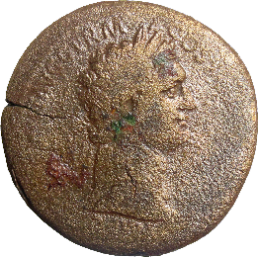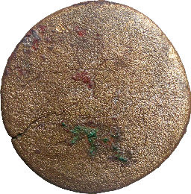

- Denomination: sestertius
Axis: 6; Diameter: 35.5 mm; Weight: 22.5 gr.
Mint: Rome
Dating: 90-91
Obverse: IMP [caes domit] AVG GERM – COS XV [cens perp p p]
Head of Domitian, laureate, right.
Reverse: legend erased.
Silhouette Jupiter seated left, holding vertical sceptre in left hand.
Reference: cf. RIC II.1, 702
Inv. No.: temp 107
Archaeological context: Cluj-Napoca, 21.08.2012, str. Deleu, C 2, grey layer, wooden phase, +338.19 m.

DOMITIANVS

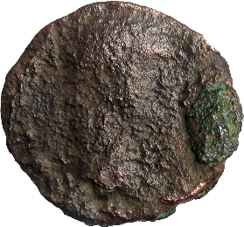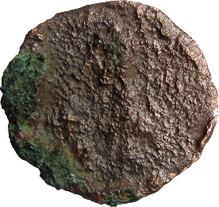

- Denomination: as
Axis: -; Diameter: 28.1 x 26.9 mm; Weight: 5.9 gr.
Mint: Rome
Dating: 81-96
Obverse: inscription erased.
Silhouette of Domitian’s head, right.
Reverse: erased.
Reference: -
Inv. No.: temp 153
Archaeological context: Cluj-Napoca, 2012, str. Deleu, wooden phase, -3.83 m.

HADRIANVS

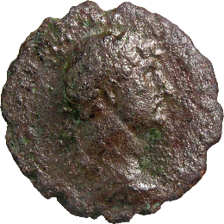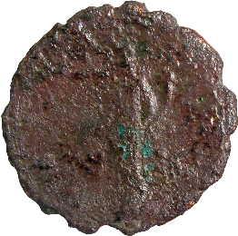

- Denomination: as
Axis: 6; Diameter: 26.5 mm; Weight: 6.4 gr.
Mint: Rome
Dating: 121-122
Obverse: [imp ca]ESAR TRA[ian hadrianus aug]
Bust of Hadrian, laureate, draped, cuirassed, right.
Reverse: inscription erased; S- C in field.
Pax, draped, standing left, holding branch downwards in right hand and cornucopiae in left
Reference: cf. RIC II, 616c
Inv. No.: temp 248
Archaeological context: Cluj-Napoca, 30.08.2012, str. Deleu, C 6, -3.57 m; level B, bottom of the pit.

HADRIANVS

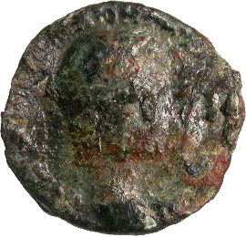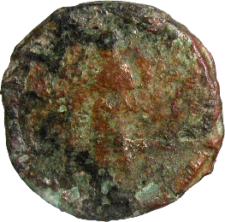

- Denomination: as - cast
Axis: 5; Diameter: 23.3 mm; Weight: 5.1gr.
Mint: uncertain
Dating: 119-122/post
Obverse: [imp caesar tr]AIAN [hadrianus aug]
Head of Hadrian, laureate right.
Reverse: inscription illegible.
Silhouette of Aequitas standing left, holding scales and sceptre?
Reference: cf. RIC II, 576
Inv. No.: temp 243
Archaeological context: Cluj-Napoca, 2012; excavated ground.

HADRIANVS

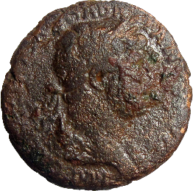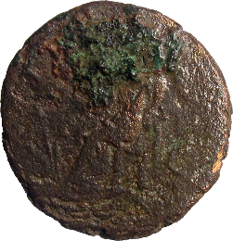

- Denomination: as
Axis: 6; Diameter: 25.7 mm; Weight: 10.5 gr.
Mint: Rome
Dating: 119-122
Obverse: IMP [caesar traian] HADR-IAN[us aug]
Head of Hadrian, laureate right.
Reverse: [p ] M T[r p cos iii]; S- C in field; exergue erased.
Reference: cf. RIC II, 617
Inv. No.: temp 111
Archaeological context: Cluj-Napoca, 22.08.2012, str. Deleu, center of lime pit, +338,05 m.

HADRIANVS

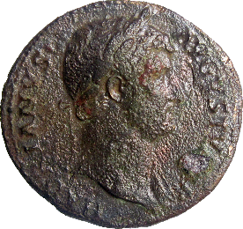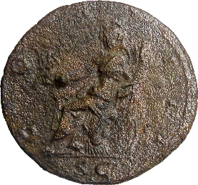

- Denomination: sestertius
Axis: 6; Diameter: 33.7 mm; Weight: 25.7 gr.
Mint: Rome
Dating: 128-132
Obverse: HADRIANVS – AVGVSTVS [p] P
Bust of Hadrian, laureate, drape of left shoulder, right.
Reverse: COS – III; S C in exergue
Roma seated left on cuirass, holding Victory in right hand and cornucopiae in left; shield and various weapons behind.
Reference: RIC II, 967c
Inv. No.: temp 108
Archaeological context: Cluj-Napoca, 21.08.2012, str. Deleu, C 2, fire layer, wooden phase, south of the lime pit, layer 19, +338.19 m.

HADRIANVS

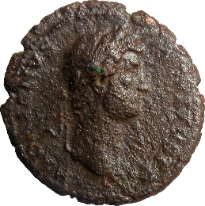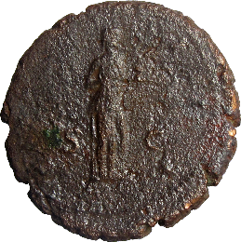

- Denomination: as
Axis: 6; Diameter: 29.2 x 28 mm; Weight: 13.8 gr.
Mint: Rome
Dating: 128-132
Obverse: HADRIANVS – AVGVSTVS P [p]
Head of Hadrian, laureate, right.
Reverse: COS – III; S – C in field.
Salus, draped, standing right, feeding out of patera in left hand snake held in right hand.
Reference: RIC II, 975b
Inv. No.: temp 124
Archaeological context: Cluj-Napoca, 21.08.2012, str. Deleu, fire layer, SW corner near the lime pit, +338,19 m.

HADRIANVS

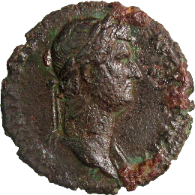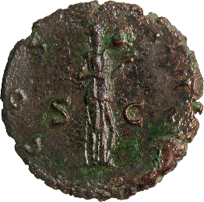

- Denomination: as
Axis: 6; Diameter: 26.3 mm; Weight: 9.9 gr.
Mint: Rome
Dating: 128-132
Obverse: HADRIANVS – AVGVSTVS P [p]
Head of Hadrian, laureate, right.
Reverse: COS – III; S – C in field.
Salus, draped, standing right, feeding out of patera in left hand snake held in right hand.
Reference: RIC II, 975c
Inv. No.: temp 213
Archaeological context: Cluj-Napoca, 29.08.2012, str. Deleu, C 6, -3.38 m, behind wall Z 11.

HADRIANVS: Sabina (Augusta)

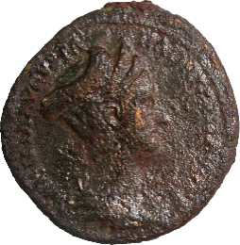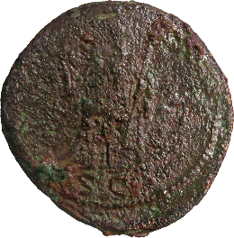

- Denomination: as
Axis: 6; Diameter: 28 x 26 mm; Weight: 13.2 gr.
Mint: Rome
Dating: 128-136
Obverse: SABINA AVGVSTA - HADRIANI AVG P P
Bust of Sabina, draped, right; hair coiled and piled on top of head behind triple tiara.
Reverse: S – C in exergue
Vesta, draped, seated left, holding palladium in right hand and sceptre in left.
Reference: RIC II, 1024
Inv. No.: temp 217
Archaeological context: Cluj-Napoca, 29.08.2012, str. Deleu, C 6, -3.44m; first half of the 2nd century AD.

ANTONINVS PIVS

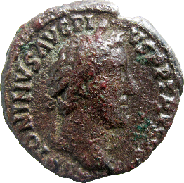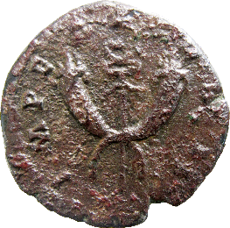

- Denomination: denarius - plated
Axis: 6; Diameter: 17.4 mm; Weight: 3.1gr.
Mint: -
Dating: 143-144/post
Obverse: ANTONINVS AVG PI-VS P P TR P COS III
Head of Antoninus Pius, laureate, right.
Reverse: IMPERATOR II
Winged caduceus between crossed cornuacopiae.
Reference: cf. RIC III, 112
Inv. No.: temp 3
Archaeological context: Cluj-Napoca, 09.08.2012, str. Deleu, C 2, from the daub of the north wall, on the floor, +340.20 m.

ANTONINVS PIVS

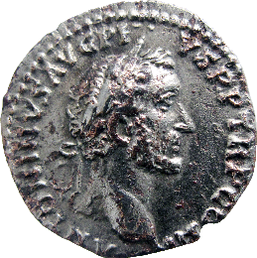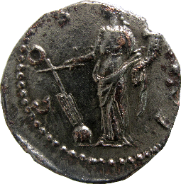

- Denomination: denarius - plated
Axis: 6; Diameter: 17.4 mm; Weight: 3.1 gr.
Mint: -
Dating: 148-149/post
Obverse: ANTONINVS AVG PI-VS P P TR P C[o]S II
Head of Antoninus Pius, laureate, right.
Reverse: COS IIII
Fortuna, draped, standing left, holding rudder on globe in right hand and cornucopiae in left.
Remark: hybrid type: obverse, RIC III, 59; reverse, RIC III, 179.
Inv. No.: temp 17
Archaeological context: Cluj-Napoca, 11.08.2012, str. Deleu, on the floor, +338.64 m.

SEPTIMIVS SEVERVS: Plautilla (Augusta)

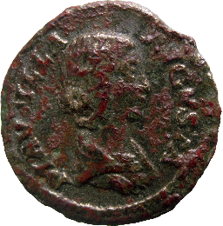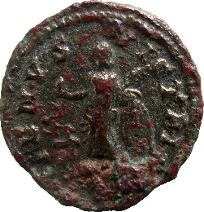

- Denomination: denarius - plated
Axis: 6; Diameter: 18.7 mm; Weight: 2.6 gr.
Mint: -
Dating: 202-205/post
Obverse: PLAVTILLA - AVGVSTA
Bust of Plautilla, hair firmly waved and drawn down on neck, draped, right.
Reverse: VENVS VICTRIX
Venus, naked to waist, standing left, holding apple in extended right hand and palm in left hand, resting left elbow on shield; at feet, left, Cupid.
Reference: cf. RIC IV.1, 369
Inv. No.: temp 2
Archaeological context: Cluj-Napoca, 09.08.2012, str. Deleu, on the floor, +340.13 m.

TRAIANVS DECIVS: Herennius Etruscus (Caesar)

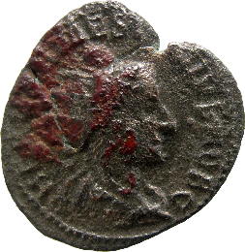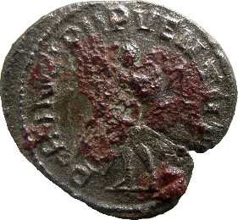

- Denomination: antoninianus - plated
Axis: 7; Diameter: 22 x 20 mm; Weight: 3.3 gr.
Mint: -
Dating: 250-251/post
Obverse: Q HE[r etr] MES [de]CIVS NOB C
Bust of Herennius Etrusucus,radiate, draped, cuirassed, right.
Reverse: PRINCIPI IPVENTVT[is]
Herennius, in military attire, standing left, holding wand in right hand and transverse spear in left hand.
Remark: Mis-spelling on reverse’s inscription: IPVENTVTIS
Reference: cf. RIC IV.3, 147c
Inv. No.: temp 65
Archaeological context: Cluj-Napoca, 16.08.2012, str. Deleu, south-west corner, C 2, +340.43 m; Roman upper layer.

Unidentifiable coin

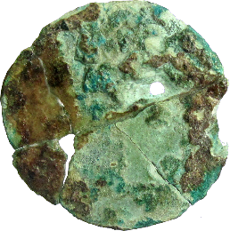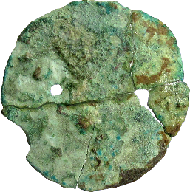

- Denomination: bronze, fragments
Axis: -; Diameter: -; Weight: -
Mint: -
Dating: 2nd-3rd c. AD
Obverse and reverse: damaged, broken.
Reference: -
Inv. No.: temp 235
Archaeological context: Cluj-Napoca, 30.08.2012, str. Deleu, C 6, -3.72m.

Unidentifiable coin

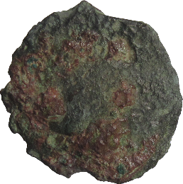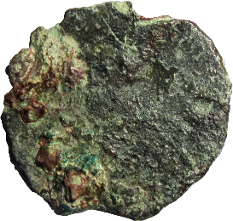

- Denomination: bronze
Axis: -; Diameter: -; Weight: -
Mint: -
Dating: 2nd-3rd c. AD
Obverse and reverse: corroded.
Reference: -
Inv. No.: temp 132
Archaeological context: Cluj-Napoca, str. Deleu, C 6, -3.73 m.

Unidentifiable coin (Medieval?)

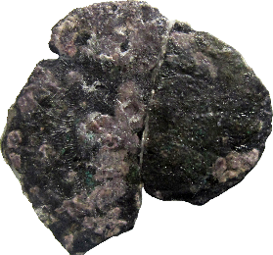

- Denomination: silver, denarius
Axis: -; Diameter: -; Weight: -
Mint: -
Dating: Middle Age
Obverse and reverse: corroded.
Remark: burnt
Reference: -
Archaeological context: Cluj-Napoca, 16.08.2012, str. Deleu, C 2, south-west corner; excavated ground.

